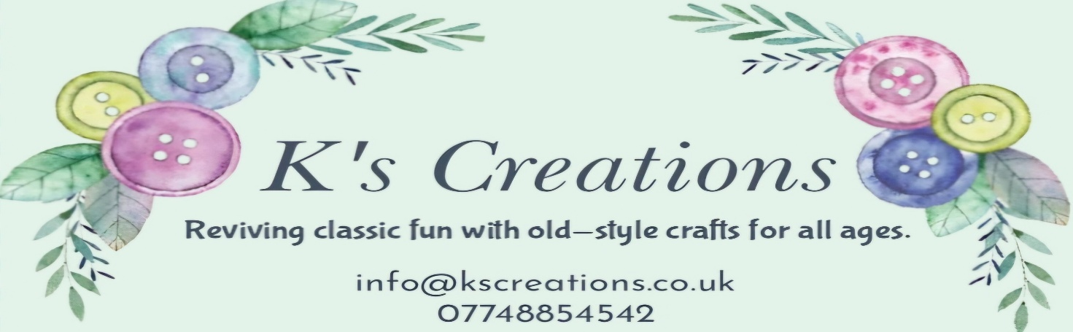
Kscreations.co.uk
Privacy Policy
Effective Date: 28.07.2025
At K’s Creations, we respect your privacy and are committed to protecting any personal information you share with us. This policy outlines how we collect, use, and protect your information, especially your email address.
---
1. Information We Collect
Your email address, when you contact us, sign up for updates, or make a purchase
Other information you choose to provide (e.g., your name, phone number, or message)
---
2. How We Use Your Email
Respond to inquiries or requests
Send updates, newsletters, or marketing (only if you opted in)
Share important service or policy updates
You can unsubscribe at any time by clicking the "unsubscribe" link in any email or contacting us directly.
---
3. How We Protect Your Information
We take reasonable steps to protect your personal data. Your information is stored securely and not shared with others except:
If legally required to do so
We do not sell or trade your email address.
---
4. Cookies and Tracking
Our website may use basic cookies to:
Understand how visitors use our site
Improve performance and user experience
You can control cookie settings in your browser.
---
5. Your Rights
You can request:
Access to your data
Correction or deletion of your information
To unsubscribe from future emails
Contact us at info@kscreations.co.uk with any requests or questions.
---
6. Contact Us
If you have any concerns or questions, please contact:
K’s Creations
Email: info@kscreations.co.uk
Website: kscreations.co.uk

